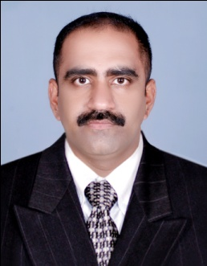

**Linto Augustine**

Mobile # +973-66385885, + 973-36964016, mail id:[lintoaugustine@gmail.com](mailto:lintoaugustine@gmail.com)

Date of Birth # 26-04-1983, Passport # M4248079 (Indian), Driving License -GCC

PERSONAL STATEMENT

* I’m a Senior Accountant looking for growing and significant career to work in professional environment
* I have previous experience in Hypermarket accounting and small business accounting

Professional Summary

* 2 years with Touch of Art trading, Bahrain –Senior Accountant (2017-Still Date)
* 8 years with Lulu Hypermarket, Bahrain – various Finance functions (2008-2016)
* 2 years with ACCOUNTS CONTRACTORS,COCHIN ,INDIA (2003-2005)

Core Competencies

* Hypermarket Accounting Management
* Floor Supervision
* Cash Management
* Inventory Management
* SAP Accounting

Experience & Strengths

* Experience in day to day Supply Accounting
* Monitoring Supplier payments and Daily cash flow
* Vendors SOA reconciliation, supplier return confirmations
* Follow up on Display agreements and In store Promotion schedules
* Daily cash collection and bank deposit reconciliation
* Monthly Stock taking and shortage reporting
* Monitoring High value materials, short expiry items, slow moving items etc.
* Pay Roll management
* Monthly Gross Profit reporting

Education

* Master in Business Administration – Information Technology, year 2005-2007
* Bachelor Degree in Commerce-2000-2003

IT Skills

* SAP – Accounts management
* Tally ERP 9
* MS Office

Reference

* Upon Request

DECLARATION

I hereby declare that all information furnished above is true to the best of my knowledge.

Linto Augustine

I